SQL Operators

🌟 Definition
# Source: AI Source: Provided by: [Data Path: Persons Table -> ID Column: 1, Name_En Column: Motasem Essam] -> From: [ChatGPT] on [6/11/2026]
SQL Operators are special symbols or keywords used to perform operations on data or compare values in SQL queries.
They are commonly used in:
- SELECT
- WHERE
- HAVING
- JOIN
- UPDATE
- DELETE
Operators help filter, compare, calculate, and combine data.

🎯 Purpose
# Source: AI Source: Provided by: [Data Path: Persons Table -> ID Column: 1, Name_En Column: Motasem Essam] -> From: [ChatGPT] on [6/11/2026]
SQL operators are used to:
- Compare values
- Filter records
- Perform mathematical calculations
- Combine conditions
- Search for matching data
- Check ranges and lists
- Test for NULL values

🧠 Simple Example
# Source: AI Source: Provided by: [Data Path: Persons Table -> ID Column: 1, Name_En Column: Motasem Essam] -> From: [ChatGPT] on [6/11/2026]
Customers Table
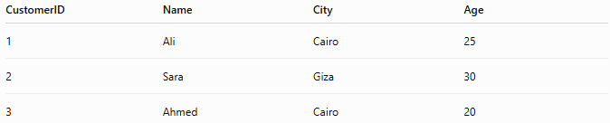
CustomerID | Name | City | Age
1 | Ali | Cairo | 25
2 | Sara | Giza | 30
3 | Ahmed | Cairo | 20

SQL Statement
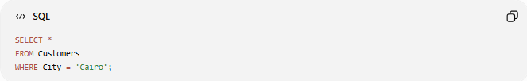
SELECT *
FROM Customers
WHERE City = 'Cairo';

Result
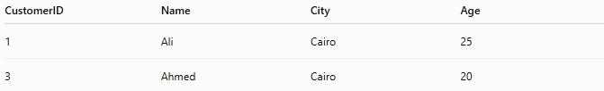
CustomerID | Name | City | Age
1 | Ali | Cairo | 25
3 | Ahmed | Cairo | 20
The **=` operator compares values.

🔢 Types of SQL Operators
# Source: AI Source: Provided by: [Data Path: Persons Table -> ID Column: 1, Name_En Column: Motasem Essam] -> From: [ChatGPT] on [6/11/2026]
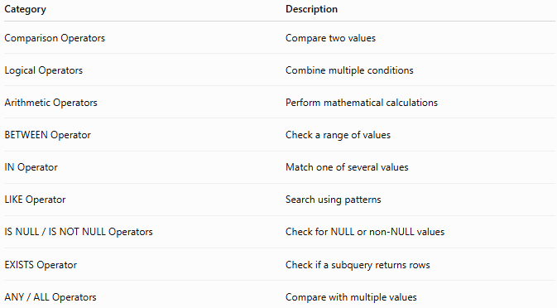
Category | Description
Comparison Operators | Compare two values
Logical Operators | Combine multiple conditions
Arithmetic Operators | Perform mathematical calculations
BETWEEN Operator | Check a range of values
IN Operator | Match one of several values
LIKE Operator | Search using patterns
IS NULL / IS NOT NULL Operators | Check for NULL or non-NULL values
EXISTS Operator | Check if a subquery returns rows
ANY / ALL Operators | Compare with multiple values

1️⃣ Comparison Operators
# Source: AI Source: Provided by: [Data Path: Persons Table -> ID Column: 1, Name_En Column: Motasem Essam] -> From: [ChatGPT] on [6/11/2026]
Used to compare two values.
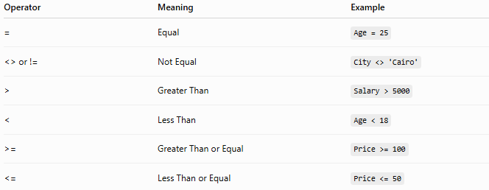
Operator | Meaning | Example
= | Equal | Age = 25
<> or != | Not Equal | City <> 'Cairo'
> | Greater Than | Salary > 5000
< | Less Than | Age < 18
>= | Greater Than or Equal | Price >= 100
<= | Less Than or Equal | Price <= 50
Example
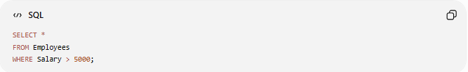
SELECT *
FROM Employees
WHERE Salary > 5000;

2️⃣ Logical Operators
# Source: AI Source: Provided by: [Data Path: Persons Table -> ID Column: 1, Name_En Column: Motasem Essam] -> From: [ChatGPT] on [6/11/2026]
Used to combine conditions.
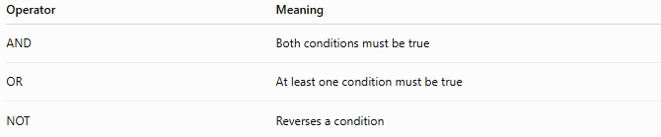
Operator | Meaning
AND | Both conditions must be true
OR | At least one condition must be true
NOT | Reverses a condition
Example
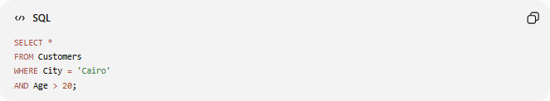
SELECT *
FROM Customers
WHERE City = 'Cairo'
AND Age > 20;

3️⃣ Arithmetic Operators
# Source: AI Source: Provided by: [Data Path: Persons Table -> ID Column: 1, Name_En Column: Motasem Essam] -> From: [ChatGPT] on [6/11/2026]
Perform mathematical calculations.
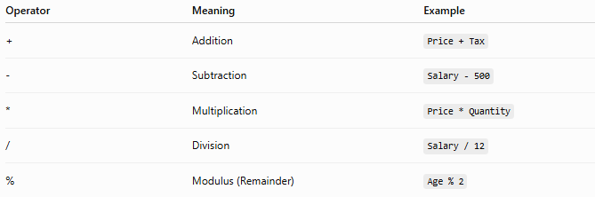
Operator | Meaning | Example
+ | Addition | Price + Tax
- | Subtraction | Salary - 500
* | Multiplication | Price * Quantity
/ | Division | Salary / 12
% | Modulus (Remainder) | Age % 2
Example
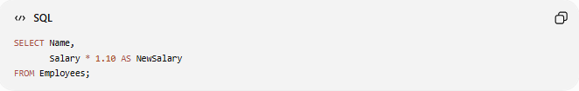
SELECT Name,
Salary * 1.10 AS NewSalary
FROM Employees;

4️⃣ BETWEEN Operator
# Source: AI Source: Provided by: [Data Path: Persons Table -> ID Column: 1, Name_En Column: Motasem Essam] -> From: [ChatGPT] on [6/11/2026]
Checks whether a value falls within a range.
Syntax
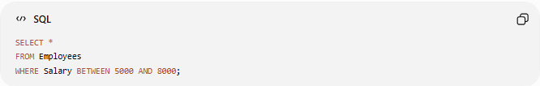
SELECT *
FROM Employees
WHERE Salary BETWEEN 5000 AND 8000;

Result
Returns employees with salaries between 5000 and 8000 (inclusive).

5️⃣ IN Operator
# Source: AI Source: Provided by: [Data Path: Persons Table -> ID Column: 1, Name_En Column: Motasem Essam] -> From: [ChatGPT] on [6/11/2026]
Checks whether a value matches any value in a list.
Example
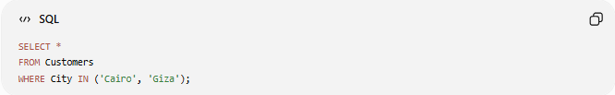
SELECT *
FROM Customers
WHERE City IN ('Cairo', 'Giza');

Result
Returns customers living in Cairo or Giza.

6️⃣ LIKE Operator
# Source: AI Source: Provided by: [Data Path: Persons Table -> ID Column: 1, Name_En Column: Motasem Essam] -> From: [ChatGPT] on [6/11/2026]
Searches using wildcard patterns.
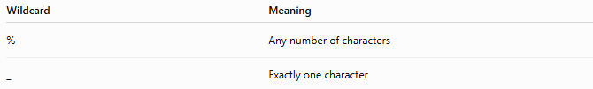
Wildcard | Meaning
% | Any number of characters
_ | Exactly one character
Example
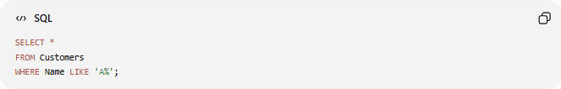
SELECT *
FROM Customers
WHERE Name LIKE 'A%';
Returns names beginning with A.

Another Example
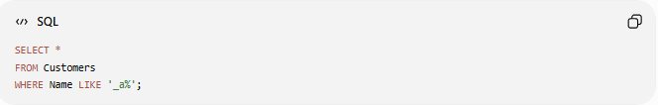
SELECT *
FROM Customers
WHERE Name LIKE '_a%';
Returns names whose second letter is a.

7️⃣ IS NULL Operator
# Source: AI Source: Provided by: [Data Path: Persons Table -> ID Column: 1, Name_En Column: Motasem Essam] -> From: [ChatGPT] on [6/11/2026]
Checks for NULL values.
Example
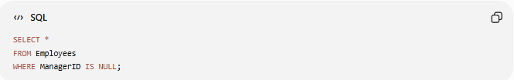
SELECT *
FROM Employees
WHERE ManagerID IS NULL;
Returns employees without a manager.

8️⃣ IS NOT NULL Operator
# Source: AI Source: Provided by: [Data Path: Persons Table -> ID Column: 1, Name_En Column: Motasem Essam] -> From: [ChatGPT] on [6/11/2026]
Checks for non-NULL values.
Example
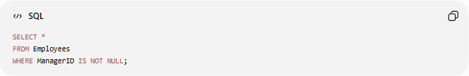
SELECT *
FROM Employees
WHERE ManagerID IS NOT NULL;
Result
Returns employees who have a manager (where ManagerID contains a value).

9️⃣ EXISTS Operator
# Source: AI Source: Provided by: [Data Path: Persons Table -> ID Column: 1, Name_En Column: Motasem Essam] -> From: [ChatGPT] on [6/11/2026]
Checks whether a subquery returns any rows.
Example
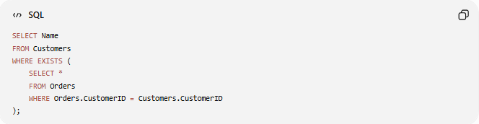
SELECT Name
FROM Customers
WHERE EXISTS (
SELECT *
FROM Orders
WHERE Orders.CustomerID = Customers.CustomerID
);
Returns customers who have placed at least one order.

🔟 ANY Operator
# Source: AI Source: Provided by: [Data Path: Persons Table -> ID Column: 1, Name_En Column: Motasem Essam] -> From: [ChatGPT] on [6/11/2026]
Compares a value with any value returned by a subquery.
Example
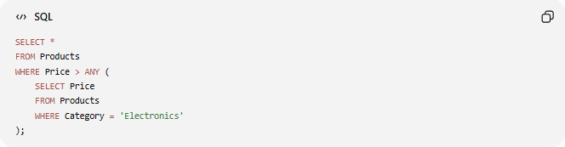
SELECT *
FROM Products
WHERE Price > ANY (
SELECT Price
FROM Products
WHERE Category = 'Electronics'
);

1️⃣1️⃣ ALL Operator
# Source: AI Source: Provided by: [Data Path: Persons Table -> ID Column: 1, Name_En Column: Motasem Essam] -> From: [ChatGPT] on [6/11/2026]
Compares a value with all values returned by a subquery.
Example
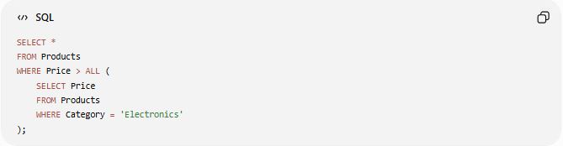
SELECT *
FROM Products
WHERE Price > ALL (
SELECT Price
FROM Products
WHERE Category = 'Electronics'
);

📊 Complete Operator Summary
# Source: AI Source: Provided by: [Data Path: Persons Table -> ID Column: 1, Name_En Column: Motasem Essam] -> From: [ChatGPT] on [6/11/2026]
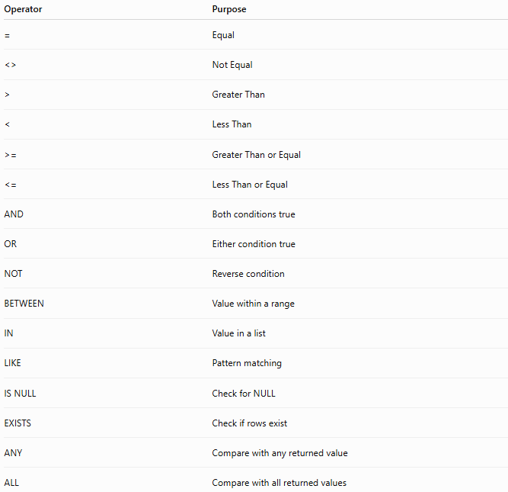
Operator | Purpose
= | Equal
<> | Not Equal
> | Greater Than
< | Less Than
>= | Greater Than or Equal
<= | Less Than or Equal
AND | Both conditions true
OR | Either condition true
NOT | Reverse condition
BETWEEN | Value within a range
IN | Value in a list
LIKE | Pattern matching
IS NULL | Check for NULL
EXISTS | Check if rows exist
ANY | Compare with any returned value
ALL | Compare with all returned values

🧪 Complete Test Example

Create Table
# Source: AI Source: Provided by: [Data Path: Persons Table -> ID Column: 1, Name_En Column: Motasem Essam] -> From: [ChatGPT] on [6/11/2026]
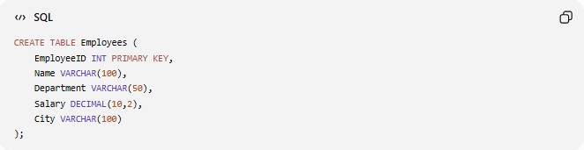
CREATE TABLE Employees (
EmployeeID INT PRIMARY KEY,
Name VARCHAR(100),
Department VARCHAR(50),
Salary DECIMAL(10,2),
City VARCHAR(100)
);

Insert Sample Data
# Source: AI Source: Provided by: [Data Path: Persons Table -> ID Column: 1, Name_En Column: Motasem Essam] -> From: [ChatGPT] on [6/11/2026]
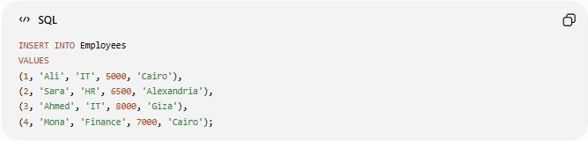
INSERT INTO Employees
VALUES
(1, 'Ali', 'IT', 5000, 'Cairo'),
(2, 'Sara', 'HR', 6500, 'Alexandria'),
(3, 'Ahmed', 'IT', 8000, 'Giza'),
(4, 'Mona', 'Finance', 7000, 'Cairo');

Example Queries

Equal Operator
# Source: AI Source: Provided by: [Data Path: Persons Table -> ID Column: 1, Name_En Column: Motasem Essam] -> From: [ChatGPT] on [6/11/2026]
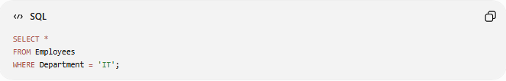
SELECT *
FROM Employees
WHERE Department = 'IT';

Greater Than Operator
# Source: AI Source: Provided by: [Data Path: Persons Table -> ID Column: 1, Name_En Column: Motasem Essam] -> From: [ChatGPT] on [6/11/2026]
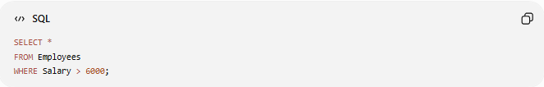
SELECT *
FROM Employees
WHERE Salary > 6000;

BETWEEN Operator
# Source: AI Source: Provided by: [Data Path: Persons Table -> ID Column: 1, Name_En Column: Motasem Essam] -> From: [ChatGPT] on [6/11/2026]
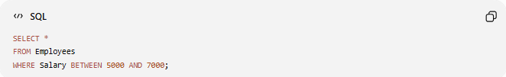
SELECT *
FROM Employees
WHERE Salary BETWEEN 5000 AND 7000;

IN Operator
# Source: AI Source: Provided by: [Data Path: Persons Table -> ID Column: 1, Name_En Column: Motasem Essam] -> From: [ChatGPT] on [6/11/2026]
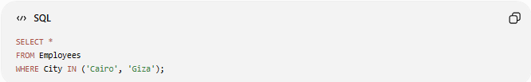
SELECT *
FROM Employees
WHERE City IN ('Cairo', 'Giza');

LIKE Operator
# Source: AI Source: Provided by: [Data Path: Persons Table -> ID Column: 1, Name_En Column: Motasem Essam] -> From: [ChatGPT] on [6/11/2026]
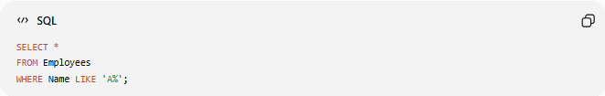
SELECT *
FROM Employees
WHERE Name LIKE 'A%';

Logical AND
# Source: AI Source: Provided by: [Data Path: Persons Table -> ID Column: 1, Name_En Column: Motasem Essam] -> From: [ChatGPT] on [6/11/2026]
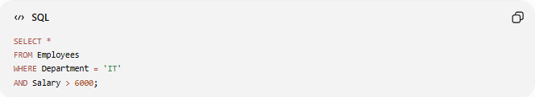
SELECT *
FROM Employees
WHERE Department = 'IT'
AND Salary > 6000;

Real Example

prepared commands

Create Table
# Source: ScreenShot Source: Provided by: [Persons Table -> ID Column: 1, Name_En Column: Motasem Essam] -> Tool: [Automation Table -> ID Column: 16, Name_En Column: Screen Capture] -> From [Operating System: Wampserver64 -> phpmyadmin] on [6/11/2026]
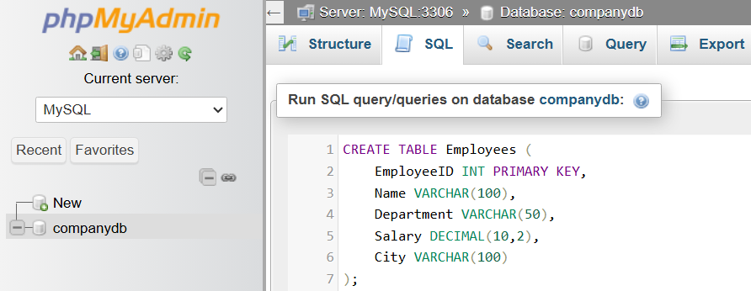
CREATE TABLE Employees (
EmployeeID INT PRIMARY KEY,
Name VARCHAR(100),
Department VARCHAR(50),
Salary DECIMAL(10,2),
City VARCHAR(100)
);
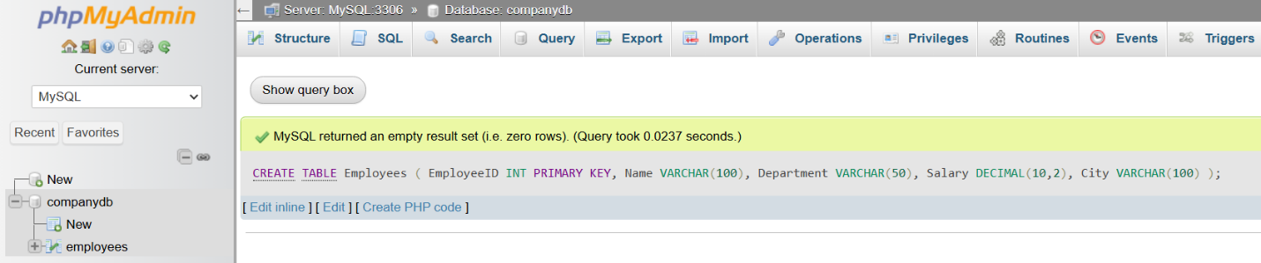

Insert Sample Data
# Source: ScreenShot Source: Provided by: [Persons Table -> ID Column: 1, Name_En Column: Motasem Essam] -> Tool: [Automation Table -> ID Column: 16, Name_En Column: Screen Capture] -> From [Operating System: Wampserver64 -> phpmyadmin] on [6/11/2026]
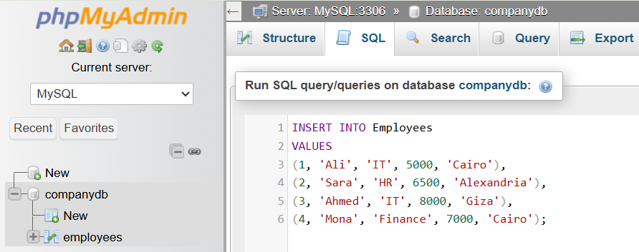
INSERT INTO Employees
VALUES
(1, 'Ali', 'IT', 5000, 'Cairo'),
(2, 'Sara', 'HR', 6500, 'Alexandria'),
(3, 'Ahmed', 'IT', 8000, 'Giza'),
(4, 'Mona', 'Finance', 7000, 'Cairo');
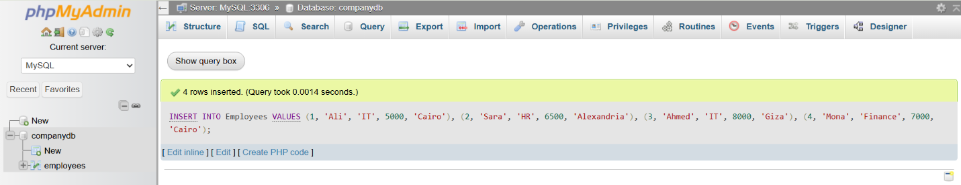

basic command

Equal Operator
# Source: ScreenShot Source: Provided by: [Persons Table -> ID Column: 1, Name_En Column: Motasem Essam] -> Tool: [Automation Table -> ID Column: 16, Name_En Column: Screen Capture] -> From [Operating System: Wampserver64 -> phpmyadmin] on [6/11/2026]
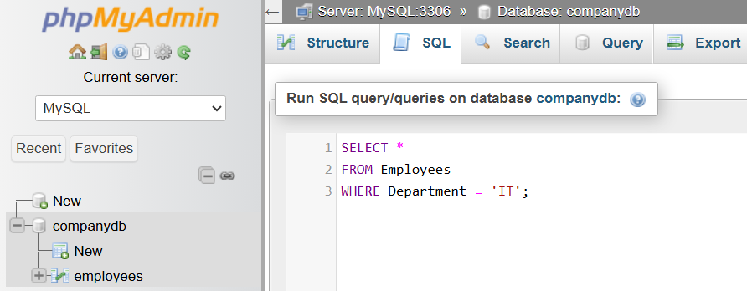
SELECT *
FROM Employees
WHERE Department = 'IT';
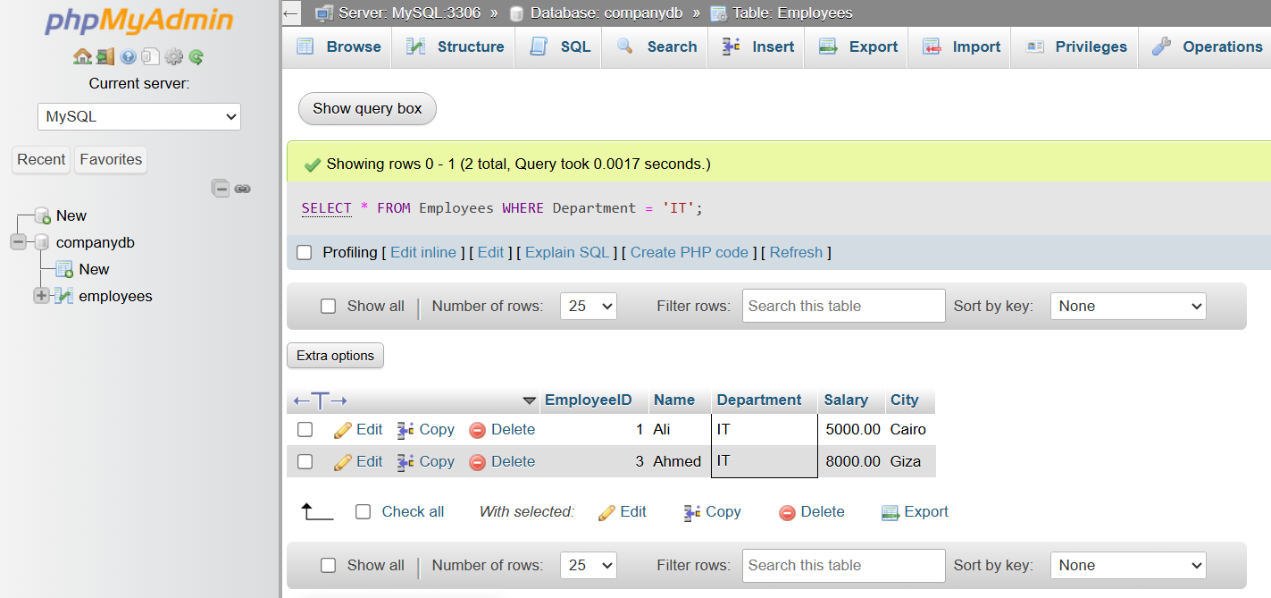

Greater Than Operator
# Source: ScreenShot Source: Provided by: [Persons Table -> ID Column: 1, Name_En Column: Motasem Essam] -> Tool: [Automation Table -> ID Column: 16, Name_En Column: Screen Capture] -> From [Operating System: Wampserver64 -> phpmyadmin] on [6/11/2026]
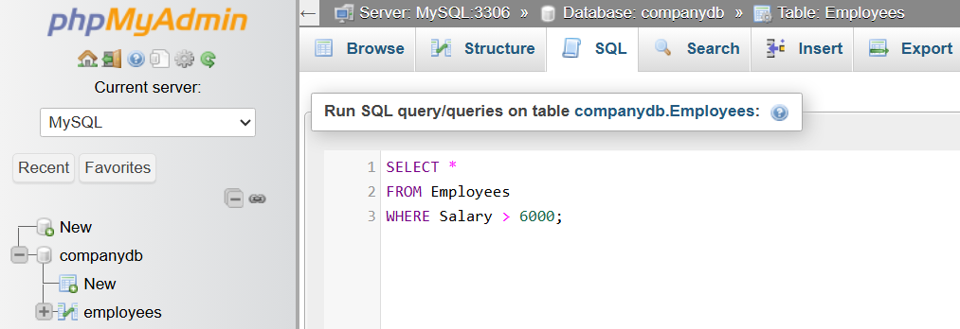
SELECT *
FROM Employees
WHERE Salary > 6000;
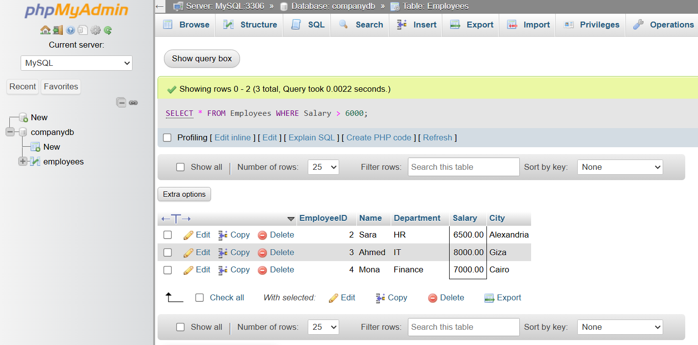

BETWEEN Operator
# Source: ScreenShot Source: Provided by: [Persons Table -> ID Column: 1, Name_En Column: Motasem Essam] -> Tool: [Automation Table -> ID Column: 16, Name_En Column: Screen Capture] -> From [Operating System: Wampserver64 -> phpmyadmin] on [6/11/2026]
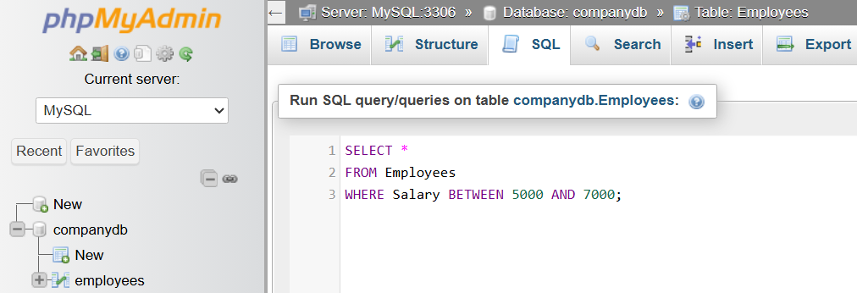
SELECT *
FROM Employees
WHERE Salary BETWEEN 5000 AND 7000;
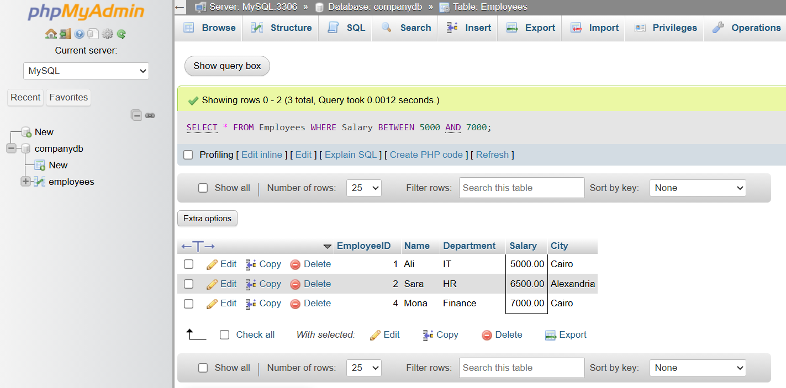

IN Operator
# Source: ScreenShot Source: Provided by: [Persons Table -> ID Column: 1, Name_En Column: Motasem Essam] -> Tool: [Automation Table -> ID Column: 16, Name_En Column: Screen Capture] -> From [Operating System: Wampserver64 -> phpmyadmin] on [6/11/2026]
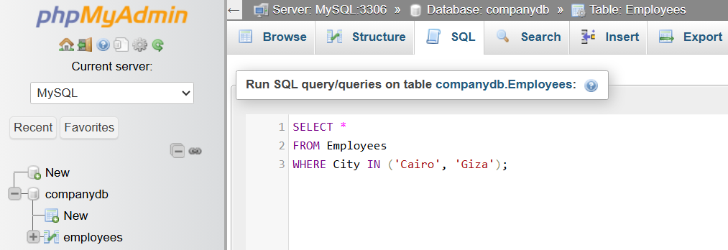
SELECT *
FROM Employees
WHERE City IN ('Cairo', 'Giza');
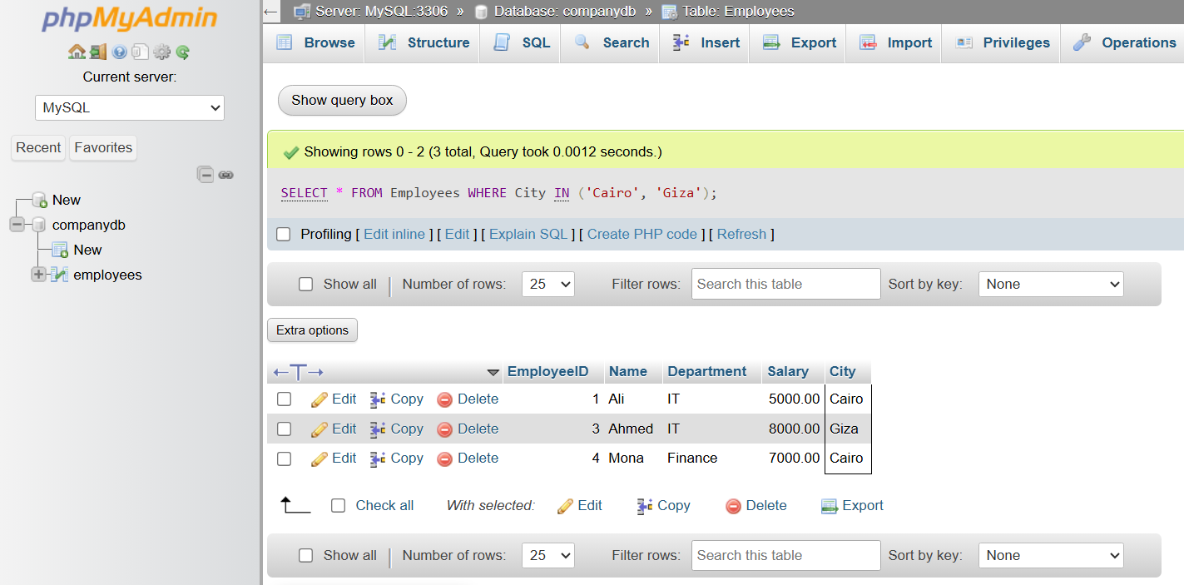

LIKE Operator
# Source: ScreenShot Source: Provided by: [Persons Table -> ID Column: 1, Name_En Column: Motasem Essam] -> Tool: [Automation Table -> ID Column: 16, Name_En Column: Screen Capture] -> From [Operating System: Wampserver64 -> phpmyadmin] on [6/11/2026]
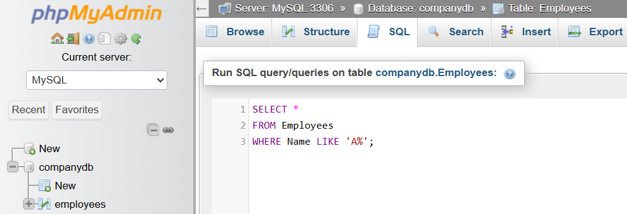
SELECT *
FROM Employees
WHERE Name LIKE 'A%';
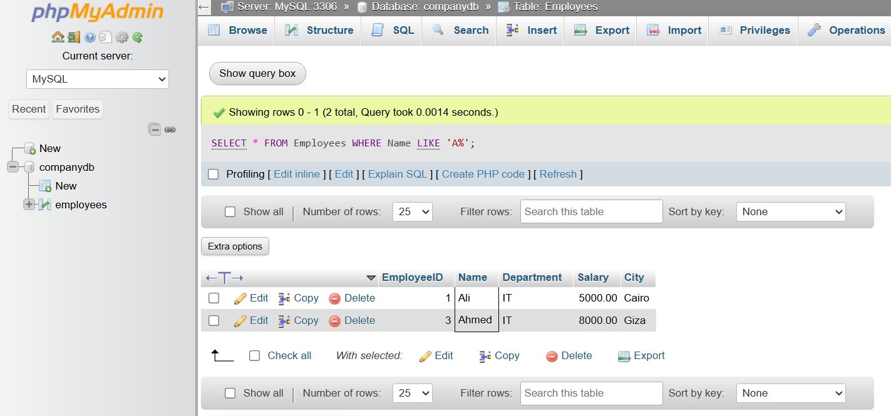

Logical AND
# Source: ScreenShot Source: Provided by: [Persons Table -> ID Column: 1, Name_En Column: Motasem Essam] -> Tool: [Automation Table -> ID Column: 16, Name_En Column: Screen Capture] -> From [Operating System: Wampserver64 -> phpmyadmin] on [6/11/2026]
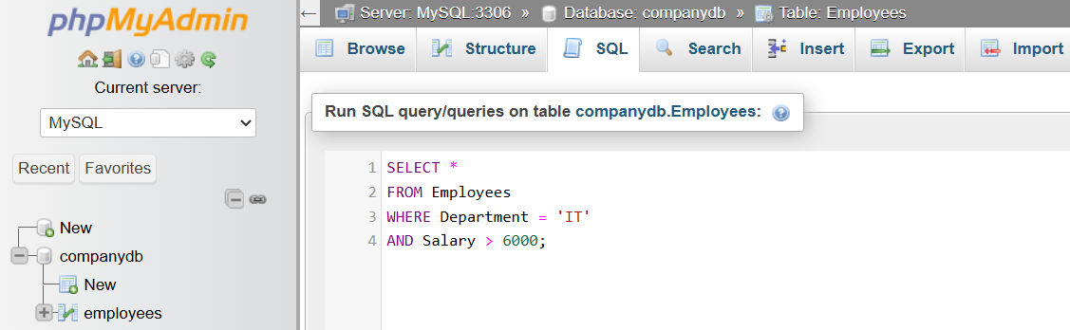
SELECT *
FROM Employees
WHERE Department = 'IT'
AND Salary > 6000;
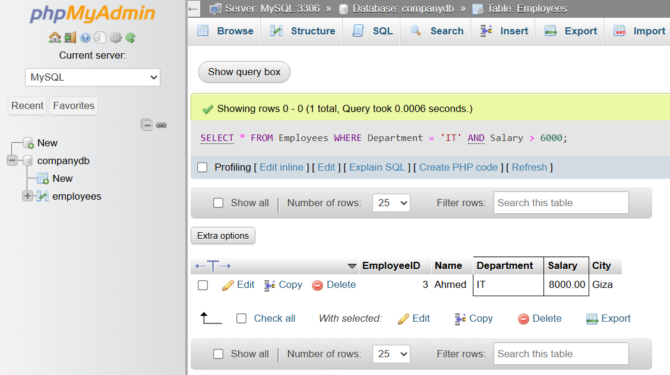

🔢 SQL Operators Workflow
# Source: AI Source: Provided by: [Data Path: Persons Table -> ID Column: 1, Name_En Column: Motasem Essam] -> From: [ChatGPT] on [6/11/2026]
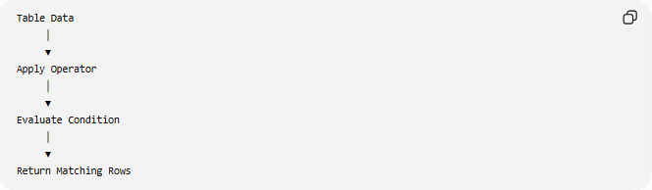
Table Data
│
▼
Apply Operator
│
▼
Evaluate Condition
│
▼
Return Matching Rows

🧠 Simple Analogy
# Source: AI Source: Provided by: [Data Path: Persons Table -> ID Column: 1, Name_En Column: Motasem Essam] -> From: [ChatGPT] on [6/11/2026]
Think of SQL operators as decision-making tools:
- = asks "Is it equal?"
- > asks "Is it greater?"
- AND asks "Are both conditions true?"
- OR asks "Is at least one condition true?"
- LIKE asks "Does this text match the pattern?"
Just as mathematical operators (+, -, *, /) perform calculations, SQL operators perform comparisons, filtering, and logical decisions on database data.

🧭 Summary
# Source: AI Source: Provided by: [Data Path: Persons Table -> ID Column: 1, Name_En Column: Motasem Essam] -> From: [ChatGPT] on [6/11/2026]
SQL Operators are symbols and keywords used to compare values, perform calculations, combine conditions, and filter data in SQL queries. They are essential for retrieving exactly the data you need and are commonly used with statements such as SELECT, UPDATE, DELETE, and clauses like WHERE, HAVING, and JOIN.

